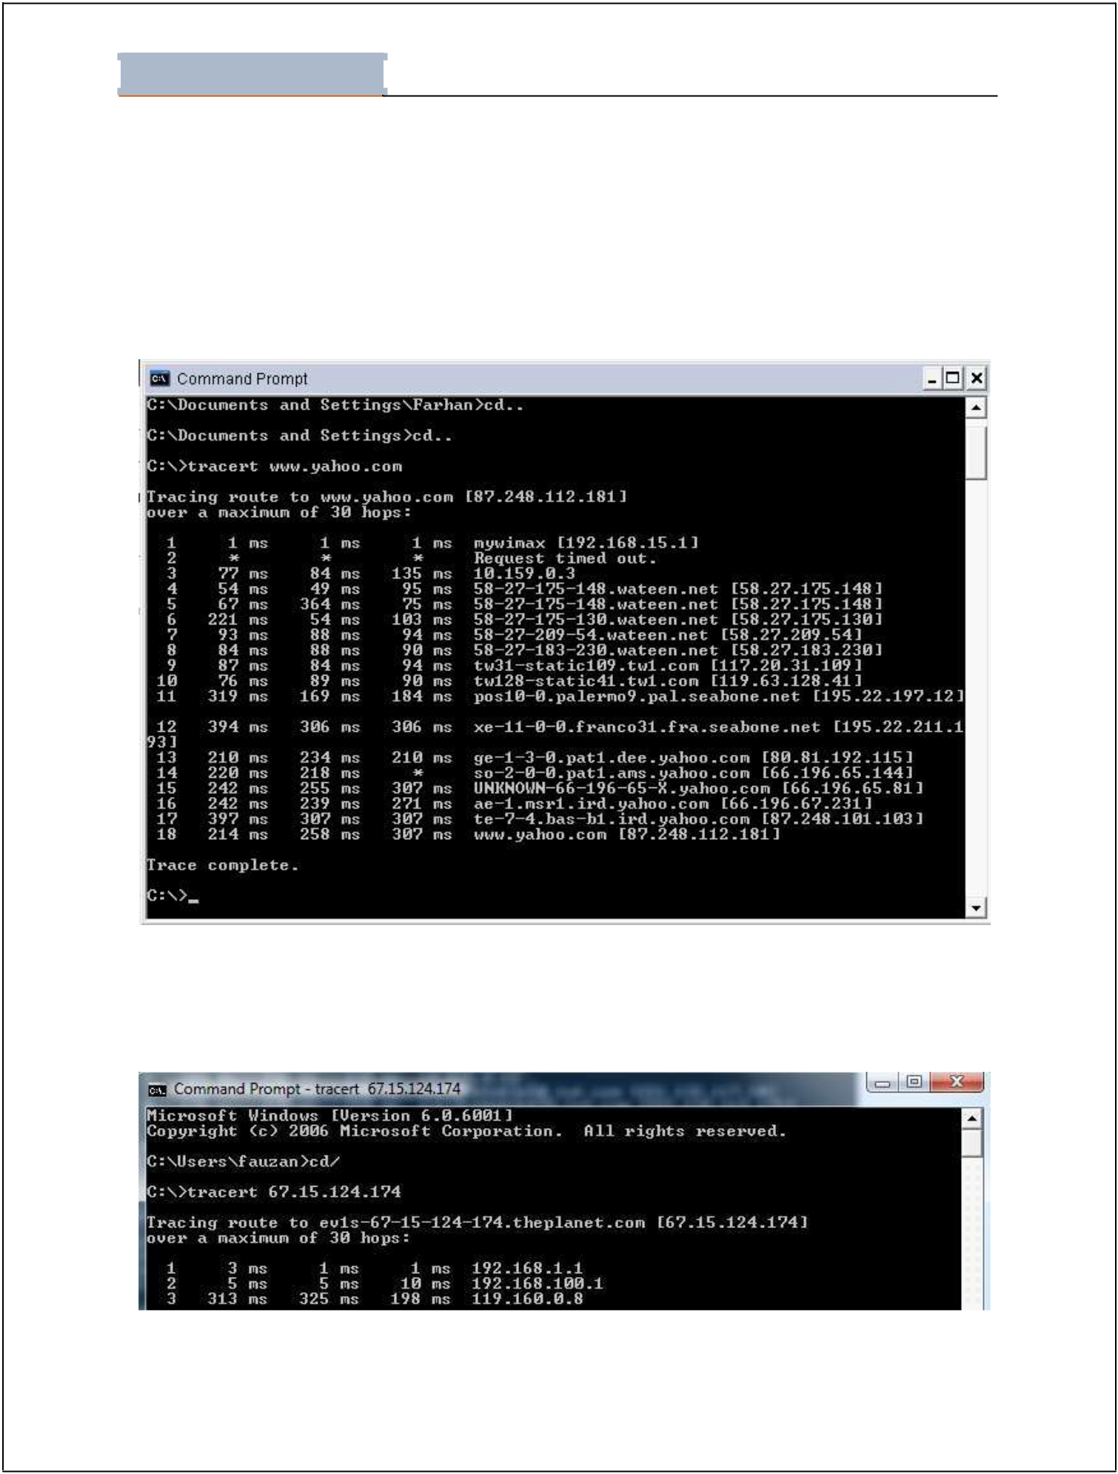
Lab - 01

Student Name: ________________________________Roll No: __________________ Section:__________

LAB # 01: TCP/IP UTILITIES

1. Tracert

Tracert is a utility that can be used to determine the route and hop count to a destinatio n.
Example of tracert is shown below:

Figure 1. Tracert

You can use IP Address instead of Domain Name

Figure 2. Tracert with Domain Name

Page 1 of 11
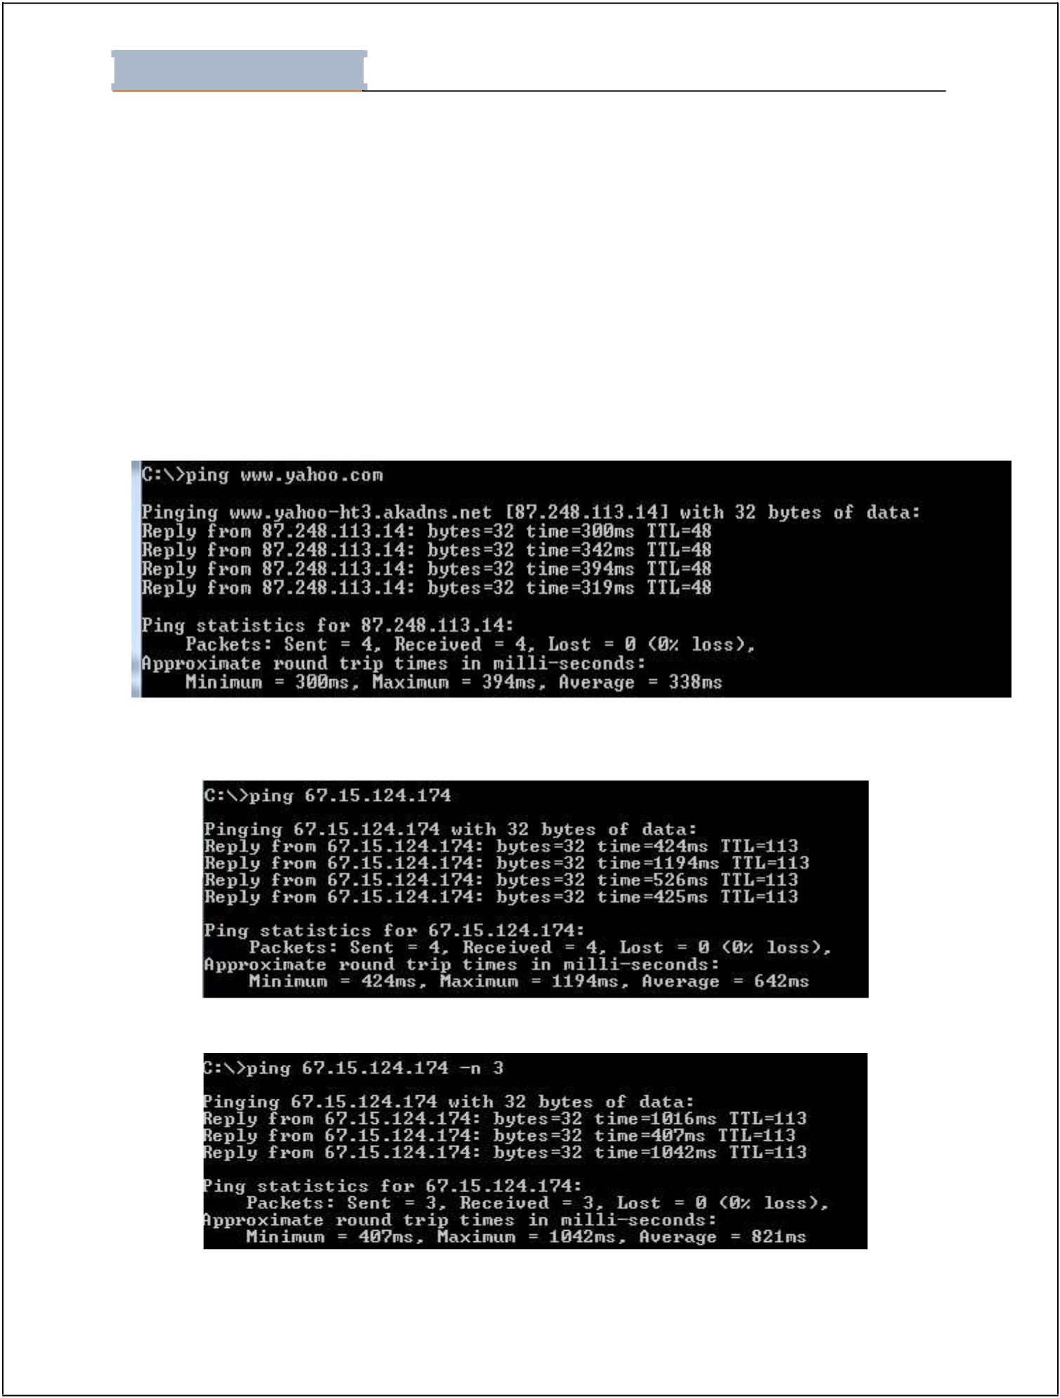
Lab - 01

Student Name: ________________________________Roll No: __________________ Section:__________

2. PING

PING stands for “Packet Internet Groper” and it is a diagnostic tool that is used to check whether a host is reachable or not. Target can be either a name or IP address.

Syntax:

Ping www.uit.edu

Ping ip address (you can mention ip address instead of domain name)

Ping ip address or Domain name –n number of packets you want to sent

Ping –a ip address.(will first resolve ip to its domain name)

Figure 3. Ping with Domain Name

Figure 4. Ping with IP

Figure 5. Ping -n

Page 2 of 11
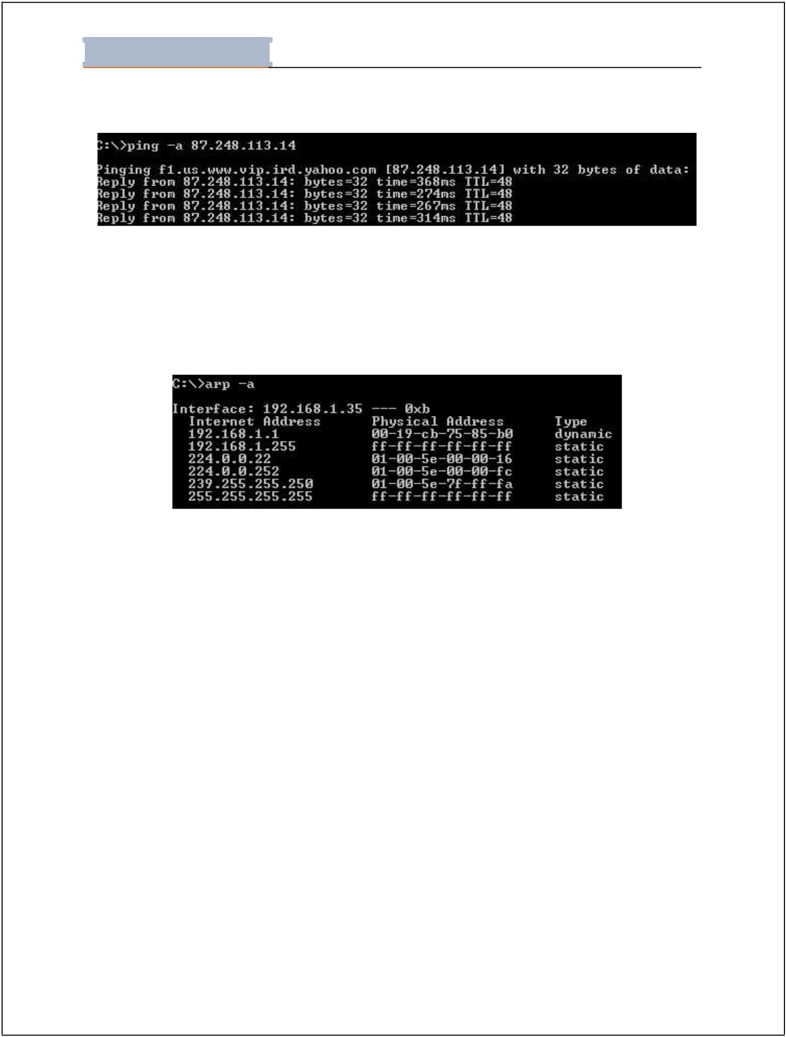
Lab - 01

Student Name: ________________________________Roll No: __________________ Section:__________

Figure 6. Ping -a

3. ARP

ARP is “Address Resolution Protocol”. It is used to resolve IP address to MAC address.

arp –a (will show a list of relevant IP addresses and their corresponding MAC addresses)

Figure 7. Arp

We can also set a MAC address against an IP address through the following command

arp –s ip address MAC address

4. Nslookup

Nslookup utility is used to test and troubleshoot domain name servers. Nslookup has two modes. Interactive mode enables you to query name servers for information about hosts and domains, or to print a list of hosts in a domain. Non- interactive mode prints only the name and requested details for one host or domain. Non-interactive mode is useful for a single query.

To enter the interactive mode of Nslookup, type nslookup without any arguments at a command prompt, or use only a hypen as the first argument and specify a domain name server in the second. The default DNS name server will be used if you don't enter anything for the second argument.

Page 5 of 11
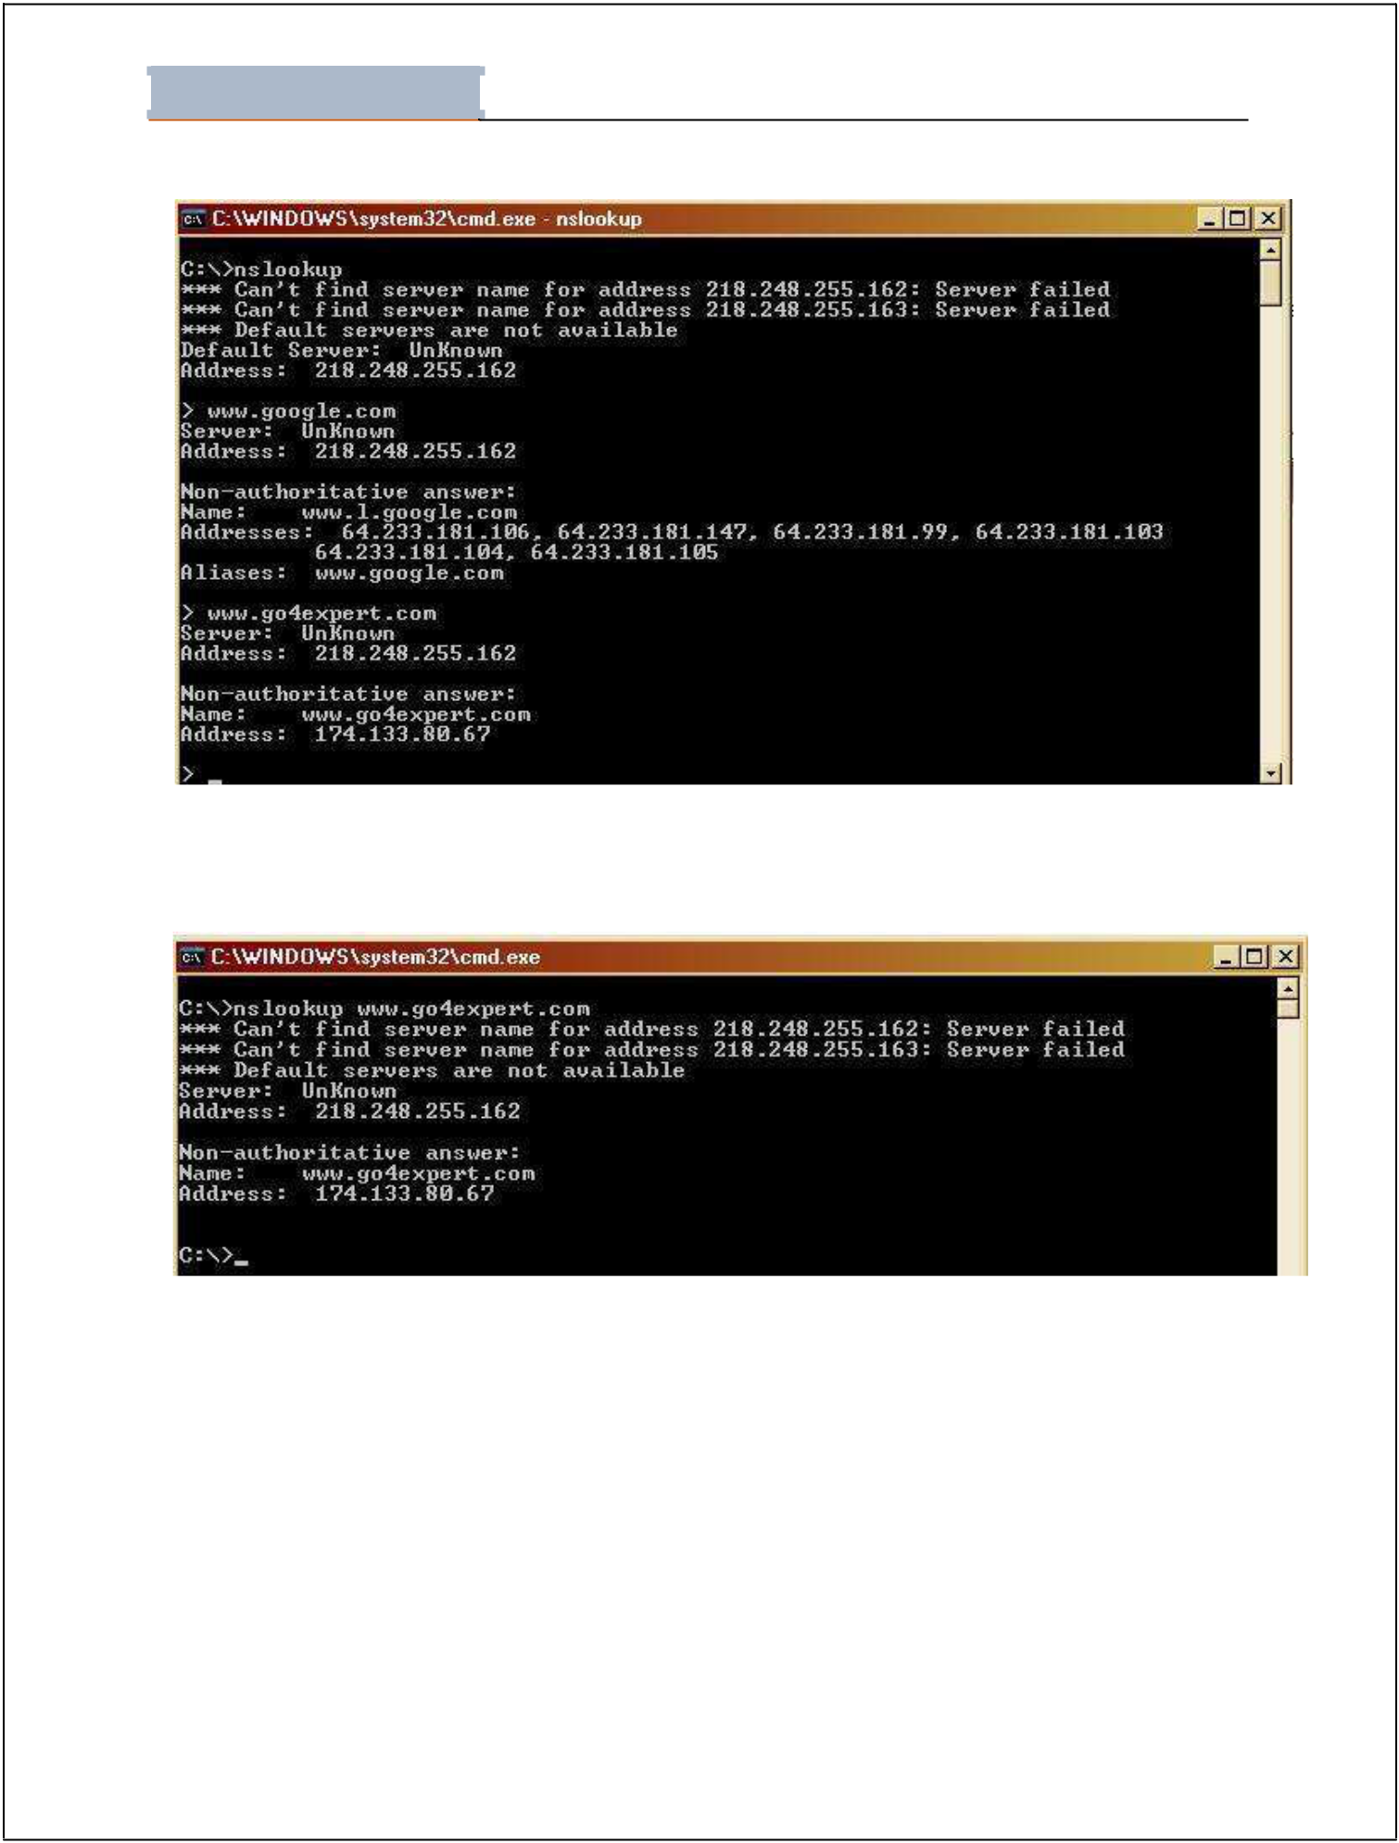
Lab - 01

Student Name: ________________________________Roll No: __________________ Section:__________

Figure 11. Nslookup

To use non-interactive mode, in the first argument, enter the name or IP address of the computer you want to look up. In the second argument, enter the name or IP address of a domain name server. The default DNS name server will be used if you don't enter anything for the second argument.

Figure 12. Nslookup with Domain Name

(note:- nslookup works equally well in unix.)

Page 6 of 11
Lab - 01

Student Name: ________________________________Roll No: __________________ Section:__________

5. Ftp

Transfers files to and from a computer running a File Transfer Protocol (FTP) server service such as Internet Information Services. Ftp can be used interactively or in batch mode by processing ASCII text files. Syntax

ftp [-v] [-d] [-i] [-n] [-g] [-s:FileName] [-a] [-w:WindowSize] [-A] [Host]

Parameters

-v : Suppresses the display of FTP server responses.

-d : Enables debugging, displaying all commands passed between the FTP client and FTP server.

-i : Disables interactive prompting during multiple file transfers.

-n : Suppresses the ability to log on automatically when the initial connection is made.

-g : Disables file name globbing. Glob permits the use of the asterisk (*) and question mark (?) as wildcard characters in local file and path names.

-s: FileName : Specifies a text file that contains ftp commands. These commands run automatically after ftp starts. This parameter allows no spaces. Use this parameter instead of redirection (<).

-a

: Specifies that any local interface can be used when binding the FTP data connection.

-w: WindowSize : Specifies the size of the transfer buffer. The default window size is 4096 bytes.

-A : Logs onto the FTP server as anonymous.

Host : Specifies the computer name, IP address, or IPv6 address of the FTP server to which to connect. The host name or address, if specified, must be the last parameter on the line.

/? : Displays help at the command prompt.


Lab - 01

Student Name: ________________________________Roll No: __________________ Section:__________

Do it Yourself

Task 01: Explore the syntax “ipconfig” and “winipcfg”. Note down your observations?

“ipconfig”Displays all current TCP/IP network configuration values and refreshes Dynamic Host Configuration Protocol (DHCP) and Domain Name System (DNS) settings.

“winipcfg” provides specific information about the computer's TCP/IP settings and configurations, such as IP and DNS addresses.

Task 02: Answer following questions

- State the size of MAC address both in Bytes and Bits.
6 bytes and 48 bits.

- Differentiate between IP and MAC address.
Both are used to identify device on a network or internet.
IP address is the logical address of a computer provided by ISP (internet service provider) while MAC address is the physical address of the device provided by manufacturer.
MAC address is of 6 bytes and IP address contains only 4 bytes.

- What is a gateway?
A gateway is a network node that serves as an access point to another network, often involving not only a change of addressing, but also a different networking technology.

- What is the purpose of loop-back address?
A loopback address is a special IP address, 127.0. 0.1, reserved by Inter NIC for use in testing network cards. This IP address corresponds to the software loopback interface of the network card, which does not have hardware associated with it, and does not require a physical connection to a network. It is used mainly for diagnostics and troubleshooting, and to connect to servers running on the local machine.

- PING stands for __Packet Internet Groper__.

- What is the difference between ipconfig and ipconfig/all commands?

Ipconfig shows the little or summarized result of IP configuration while ipconfig/all gives a detailed analysis of IP configurations

- What is Nslookup stands for? What is the significance of this utility? What is Non-authoritative answer?

Nslookup is a network administration command-line tool for querying the Domain Name System (DNS) to obtain domain name or IP address mapping, or other DNS records. It is principally used to find the IP address that corresponds to a host, or the domain name that corresponds to an IP address (a process called “Reverse DNS Lookup”).

nslookup is used to troubleshoot server connections or for security reasons. Such reasons include guard against phishing attacks, in which a domain name is altered.
Non authoritative answer are those in which we write a domain which can not be exist.

- Write a command to transfer “abc.txt” file from PC having IP address

192.168.2.21 to PC having IP address 192.168.100.1. Also write a command to get the same file from the PC having IP address 192.168.100.1.


Lab - 01

Student Name: ________________________________Roll No: __________________ Section:__________

11 of 11

